Tamariki
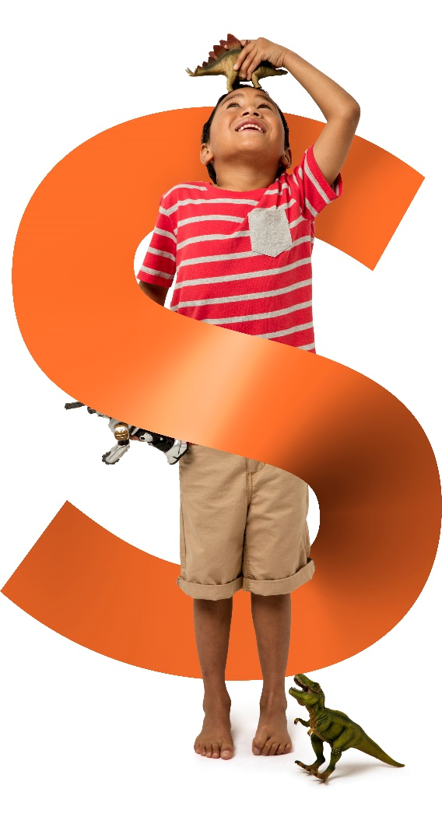
ACTIVITY BOOK

Count the money in each pocket and write down the amount that each pocket has in it.
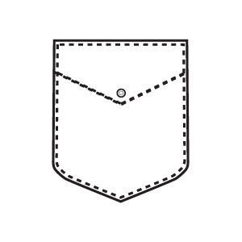
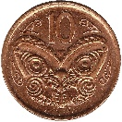
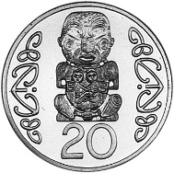
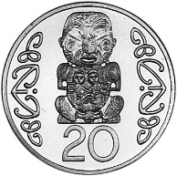
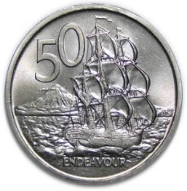

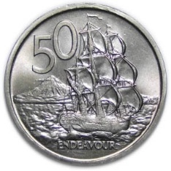
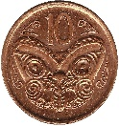
¢………………….
¢………………….
¢………………….
¢………………….

Colour the piggy bank

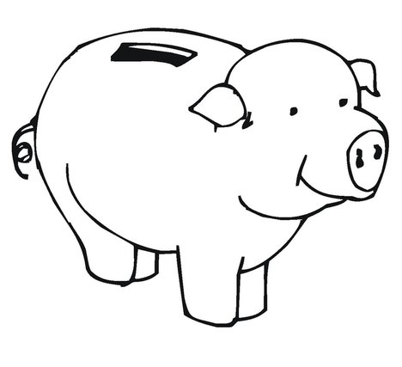

Draw a line from the coin to the correct word

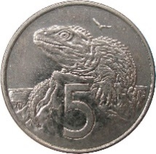
Kiwi

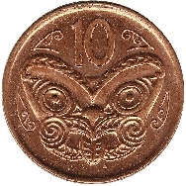

Ship

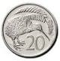

Taniwha

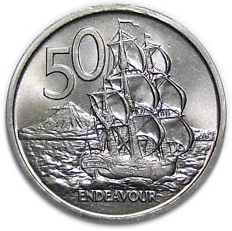
Tuatara

Word Find

S | A | I | C | C | V | C | E | X | R | I | T | P | Q | R
T | S | R | E | B | M | U | N | T | C | W | E | W | T | S
N | O | N | E | D | O | L | L | A | R | A | N | K | M | X
E | F | U | Y | R | W | I | J | S | E | S | C | Q | P | O
C | T | I | P | R | T | A | A | T | T | J | E | Z | K | R
Y | Z | O | V | J | U | V | U | N | V | U | N | Q | H | P
T | T | A | M | E | I | P | E | Z | W | J | T | Y | W | D
N | U | Q | A | N | C | C | V | O | W | Y | S | E | P | A
E | Q | P | G | C | Y | E | J | R | H | Q | Y | N | D | K
W | L | S | O | T | I | A | N | J | A | M | R | O | W | H
T | R | N | F | E | G | L | L | T | A | L | S | M | C | R
D | P | I | K | O | H | A | K | E | S | J | L | W | Z | O
B | F | I | X | V | H | S | U | O | K | T | V | O | H | X
U | M | C | K | R | Z | Q | D | O | H | E | L | G | D | L
X | O | W | Y | W | U | I | J | L | T | P | L | W | Z | W

DOLLAR | FIFTYCENTS | FIVECENTS
KOHA | MONEY | NUMBERS
ONEDOLLAR | PUTEA | SAVINGS
TENCENTS | TWENTYCENTS

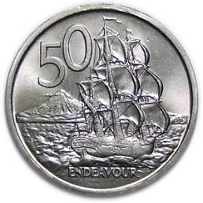
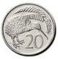
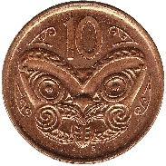
$.........……….
¢………………….
$.........……….

Add up the coins to buy each item

